DIY Room Air Cleaner v1.1

What is smog

Smog = smoke + fog is a mixture of pollutant gasses, microscopic particulates and moisture in the air. Gasses and particles are produced in stationary furnaces and in internal combustion engines of vehicles.
Gasses such as CO, CO₂, NO, NO₂, SO₂ easily dissolve in atmospheric water and transform into acids, carbonic, nitric, sulfuric etc. which corrode everything that they come in contact. If those are breath in, sensitive moist lung tissue gets damaged and irritated. Over time irritation leads to serious diseases such as asthma and cancer. Smog is utterly detrimental to children causing irreversible damage.
Microscopic soot particulates usually contain heavy metals such as mercury and lead, as well as carcinogenic organic compounds. They also act as centers of concentration of all other pollutants because moisture from air tends to condense over particulate surface providing means for gasses to form acids. Thus by breathing in particulates, we let significantly more extremely dangerous substances of all kinds enter our body. Acidic envelope is the very reason that smog particulates typically smell and taste sour and irritate eyes. Because of that, WHO declared smog particulates a type I carcinogen.
Two types of smog particulates are monitored: those smaller than 2.5 µm (two-and-a-half thousandths of a mm) in diameter, and those smaller than 10 µm. As a comparison, human hair is ~ 30 µm thick. All particulates are detrimental, but the smallest ones are the most dangerous of all as they are able to travel deeply into lungs and even to enter blood stream; breathing them in leads to serious diseases of heart and other internal organs.
Particulate concentration in air is denoted PM 2 . 5 and PM 10, and is expressed in µg / m³ (micro-gram i.e. millionth part of a gram per cubic meter). Perfectly clean air does not contain particulates, while air containing more than 60 µg/m³ PM_{2.5} or 100 µg/m³ PM₁₀ is considered very unhealthy.
Because pollutants are highly concentrated on particulate surface, by removing particulates from air mechanically, we significantly lower the amount of dangerous substances being breath in, reducing the risk of developing chronic life threatening diseases.

This instruction manual is very detailed because its purpose is to enable even those not skilled in DIY craft to make the device on their own at home. Please read the entire manual thoroughly in order to get acquainted with the process before commencing labor. A single afternoon is quite enough for making the device.
The author of this manual can except no responsibility for possible damage or injuries that might be caused by making or using this device. The decision whether you want to build and use it is solely your own. Please work carefully and responsibly, and do not use the device should you encounter any irregularities in its operation.

What can be expected from DIY room air cleaner

Device described here is able to maintain good quality of air inside a single room 24 / 7.

Room air cleaner operates by sucking in the surrounding air through a special filter on its bottom and then expelling the cleaned air out by a pair of small PC fans.

A pair of PC fans is sufficient for processing ~ 1 m³ of air per minute. Starting with very dirty air, this device will clean the entire volume of air within a typical room in approximately 2 hours after closing the door and windows.

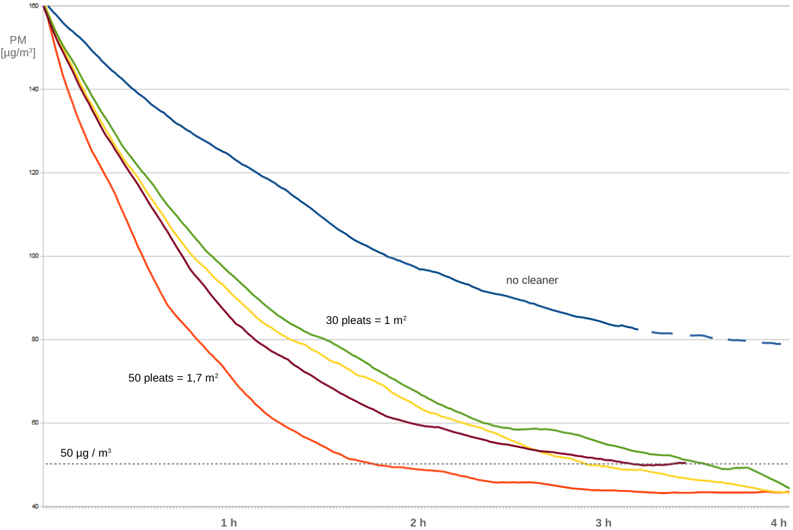

The key component of a room air cleaner is its filter. Perfect filter material for cleaning air is HEPA (High Efficiency Particulate Absorbing). Unfortunately for DIY-ers, HEPA is hard to get in the form of raw material. In addition, it requires air pumps with significantly higher suction power than a pair of PC fans has.

Material that is relatively easy to get is denoted class F9 (Fine filter, highest grade 9). It consists of interwoven fiberglass fibers of micrometer diameter and is somewhat less efficient than HEPA in capturing particulates. The difference in particulate absorbing efficiency between F9 and low-grade HEPA dedicated for home use is not very high though, and typically amounts to 25%.

The advantage of F9 over HEPA is its lower cost and much lower resistance to the flowing air. A room air cleaner made with F9 can thus process more air per minute in comparison to the otherwise equal one made with HEPA. In real life conditions such two cleaners will have similar cleaning ability.

F9 room air cleaner is very efficient in eliminating cigarette smoke, allergens such as pollen, fungal spores and mite produce, as well as domestic house dust.

Material and components

- pleated F9 filter material 40 cm wide, from 30 to 50 pleats (i.e. cross-sectional „V“-s)

- one standard construction cardboard plate 3 mm thick, 100 x 70 cm

- one hot glue stick

- one half of a standard 280 ml acrylic silicone tube, often used in construction works

- two 8 x 8 cm or 12 x 12 cm PC fans, designed for 12 V DC power supply

- one miniature DC-DC boost converter

- one 5V / 2A mobile phone charger or similar AC / DC converter able to deliver 10 W

- two-wire cable of appropriate length for connecting the air cleaner to the power source

- USB connector or USB cable, if the device will be powered by a mobile phone charger

- small power switch, not necessary

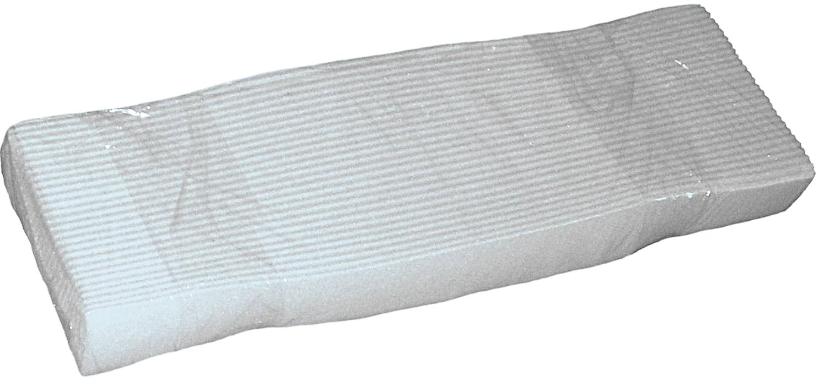
- electrical insulating tape

- old newspaper

- paper towel

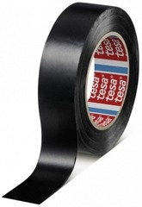
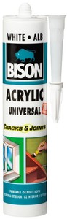
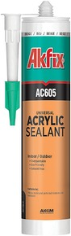
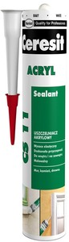
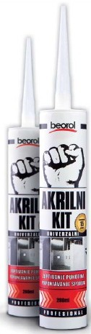
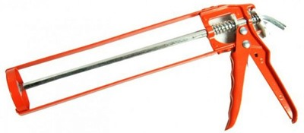
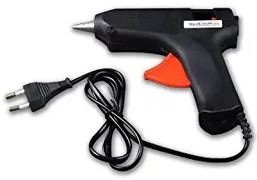
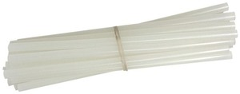
Pleated F9 raw material typically costs ~0.5 EUR per pleat 40 cm wide. In some countries it is possible to buy framed 40 x 40 cm filter packs, in which case building this device is a bit easier.

Construction cardboard costs ~1.5 EUR per standard 100 x 70 cm plate. It can be bought in bookstores, office or art supply shops.

Hot-glue and acrylic silicone can be found e.g. in DIY raw material stores. Hot glue stick costs ~0.2 EUR, while acrylic silicone tube costs ~1.5 EUR.

PC fans can be bought in computer shops. The cheapest 8 x 8 cm PC fans cost ~1.5 EUR a piece, while 12 x 12 cm models are twice as expensive. Bigger fans are usually more powerful and at the same time less noisy and longer lasting, but the difference in air cleaning speed between the devices built with 8 vs 12 cm fans will not be greater than 25%. So we recommend buying a pair of cheapest 8 cm fans.
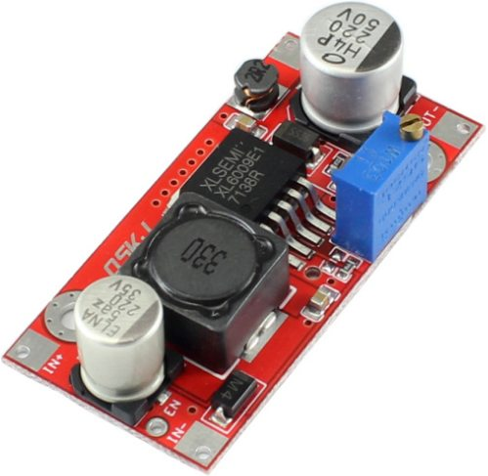
DC-DC converter boosts voltage from 5 V at its input to 17 V at the output. PC fans designed for 12 V DC will be connected to 17 V in this device in order to raise their suction power. All PC fans that we have tested worked OK at 17 V.

Miniature DC-DC boost converters are standard electronic components easy to get via electronic component suppliers or online. Model with XL6009 chip in the picture to the right is 4.5 x 2.5 cm and costs ~2 EUR.

Cable used for supplying the cleaner with power should be insulated flexible 2 x 0,5 mm² to 2 x 1 mm² copper wire. The cheapest such cables are „loudspeaker cables“ colored red-and-black or dim yellow. They typically cost ~0.2 EUR per meter.

USB connector can be bought via electronic component suppliers or online. It costs ~0.4 EUR. You can also use a piece of a standard USB cable with cast USB connector on one of its sides.

Tools

You will need some tools, that you can borrow from a friend:

- plastic ruler or metal measuring tape

- a pencil or a pen

- cardboard box cutter

- small hot glue „gun“

- silicone „gun“

- soldering iron with some tin wire and soldering paste

- miniature screwdriver for setting DC-DC converter output voltage

- digital DC voltmeter

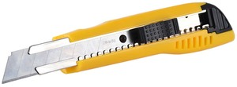

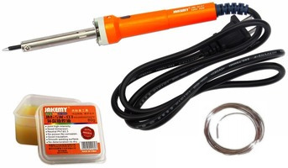

Making the box

1.

Mark a pair of dots (a and b) at precisely 15 cm from one of the shorter sides of the cardboard, and then another pair (c and d) approximately 5 cm from the same side. If there is no sufficiently long straightedge at hand, draw an approximately straight line between dots c and d:

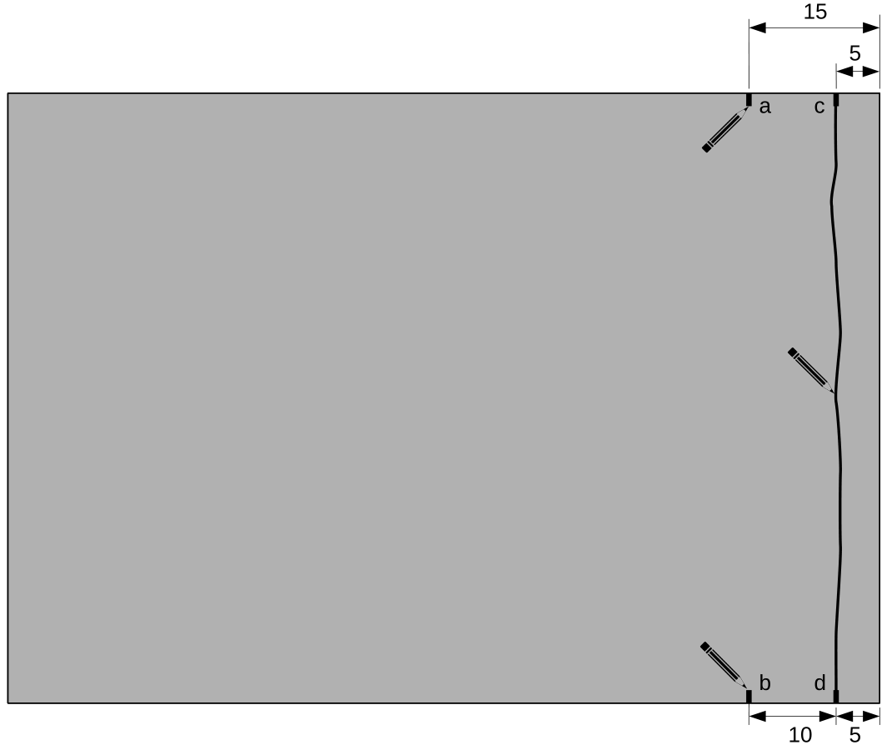

This first line is not critical but give your best to make it relatively clean and straight.

Precision of approx. 1 mm will be required for all the following lines so please remember to take your time when drawing them.

Think twice before you cut.

2.

Put an old newspaper underneath the cardboard (the line) in order not to cut the floor. Using the box cutter, carefully cut the plate along the line, here denoted „s“:



Remember to move the newspaper as you cut.

It takes three to four passes of the cutter along the line to cut through the plate entirely. You do not need to perform high pressure while cutting - use only a light touch to lead the tip of the cutter with perfect control and precision.

The first pass is crucial because a line once missed is very hard to fix later.

WARNING!

Never put your fingers in the direction the cutter is moving!

Put the cutter down as soon as you finish cutting!

Otherwise you are very likely to cut yourself by swinging the sharp edge around.
3.

Cardboard piece „S“ that you have just cut out will serve as a nice straightedge in the following steps.



Remember to use its perfectly straight outer edge.
4.

Using S as a straightedge, draw a straight line between dots a and b marked in the first step:

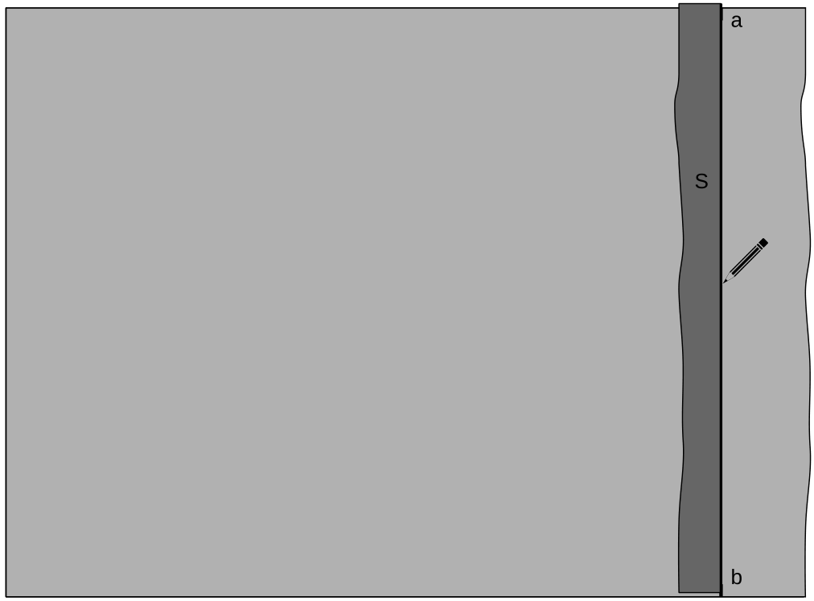

5.

Put the old newspaper underneath the cardboard and then carefully cut the plate along the line:



The first pass is crucial because a line once missed is very hard to fix later.

For the sake of precision, we recommend that the first passage of the cutter be very slow, merely 1 cm per second.

6.

You will not need a piece of cardboard denoted X if you have a single-piece filter material pack.



If you have a filter pack consisting of two halves (each 20 cm wide), you will cut out a 40 x 5 cm rectangle from X and use it as a girder put between the halves.
7.

Mark the dots on opposite edges of the cardboard plate and draw the lines as depicted below:

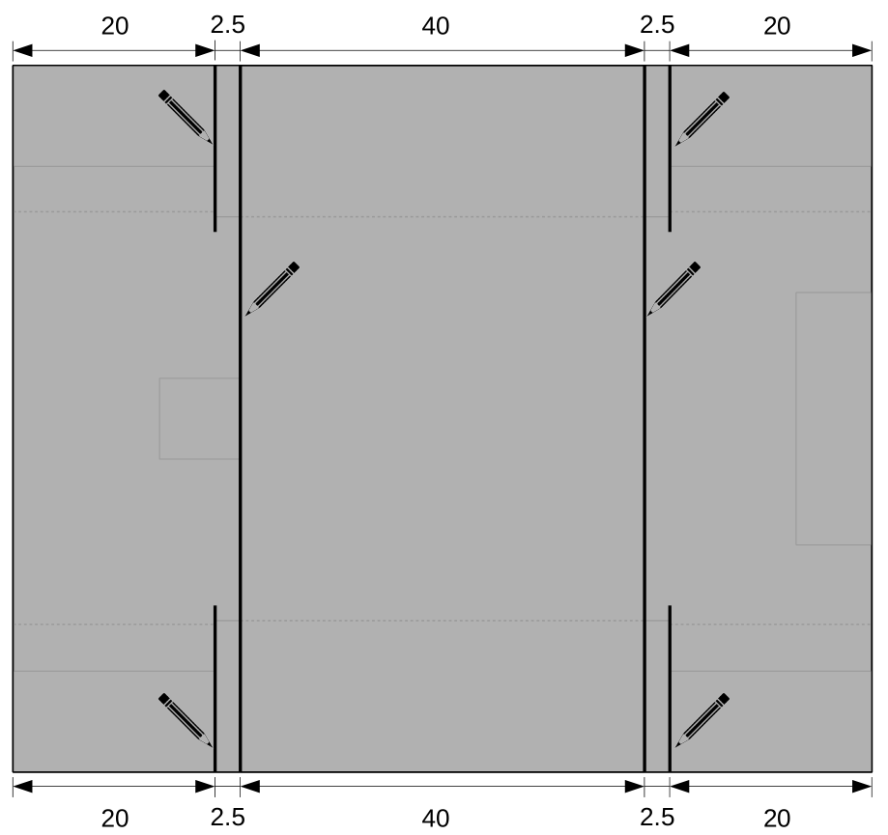

8.

Mark the dots and draw the lines as depicted below:

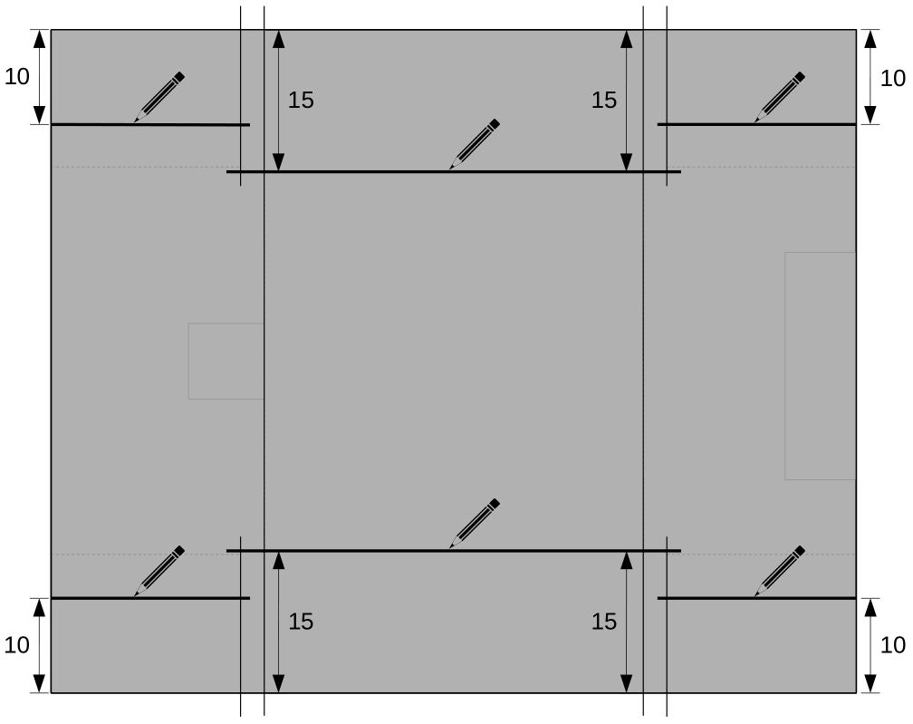

9.

You should produce a line drawing as below:

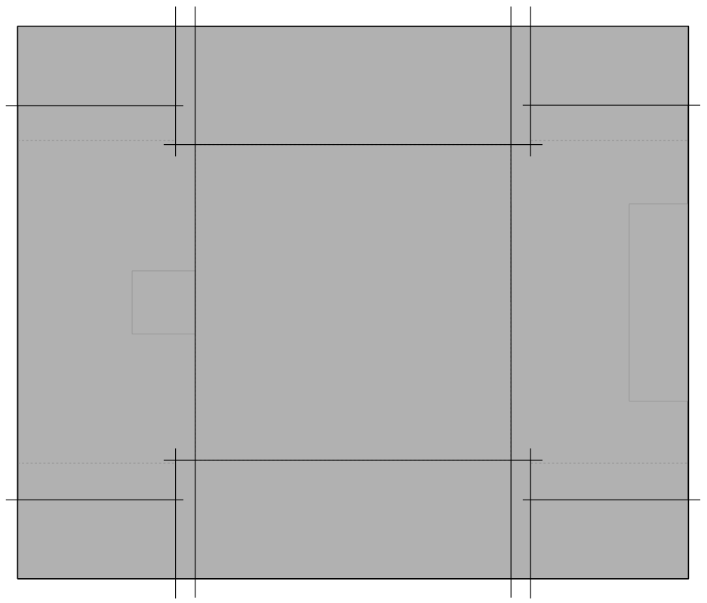

10.

Put the old newspaper underneath the cardboard and then carefully cut along the lines from 1 to 8:

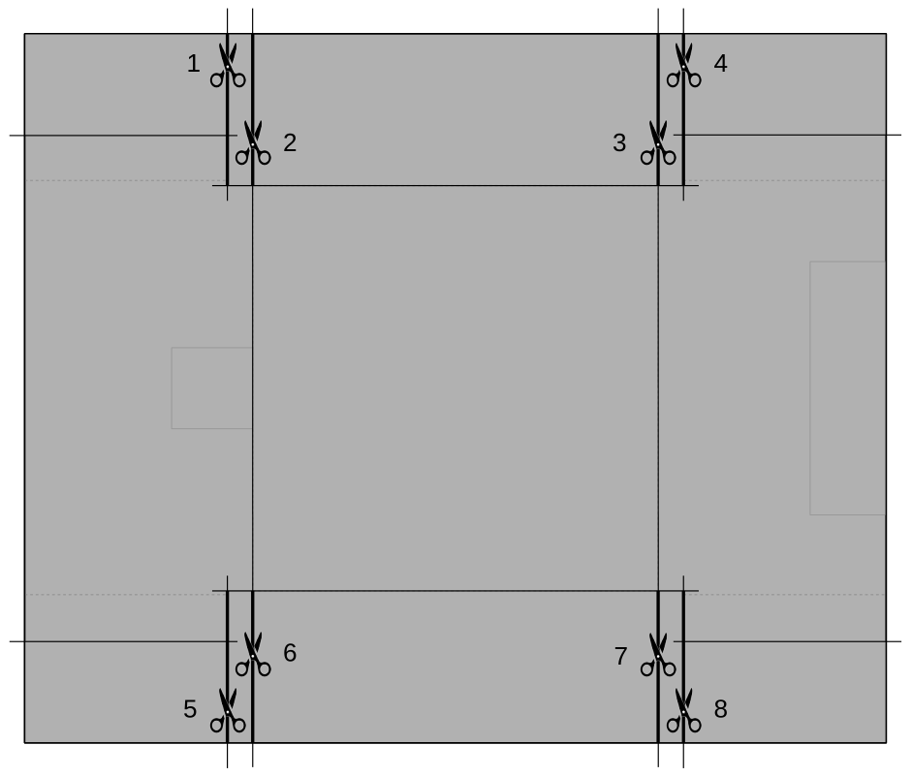

Take care not to cut too much material in the central part of the cardboard – do not cut any further than the crossing lines. This is easiest to prevent by cutting the cardboard starting from center and pulling the cutter towards the edge.

11.

Cut along the lines from 9 to 12:

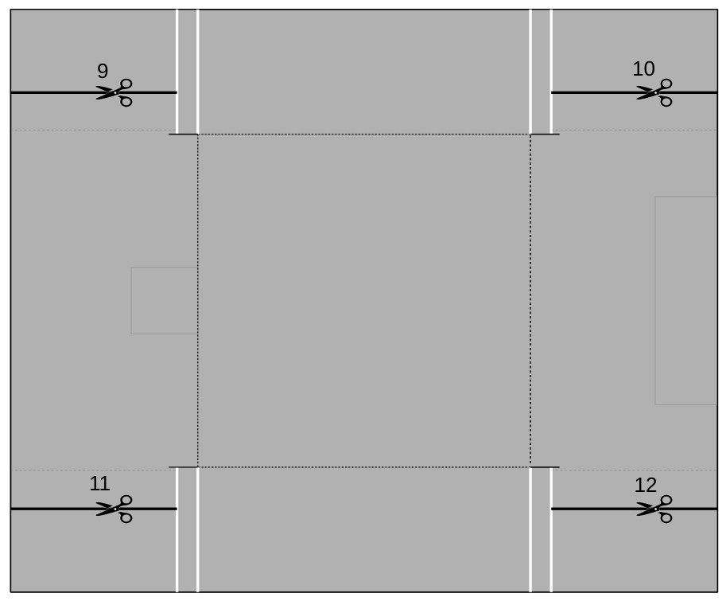

12.

Cut along the short lines from 13 to 16:

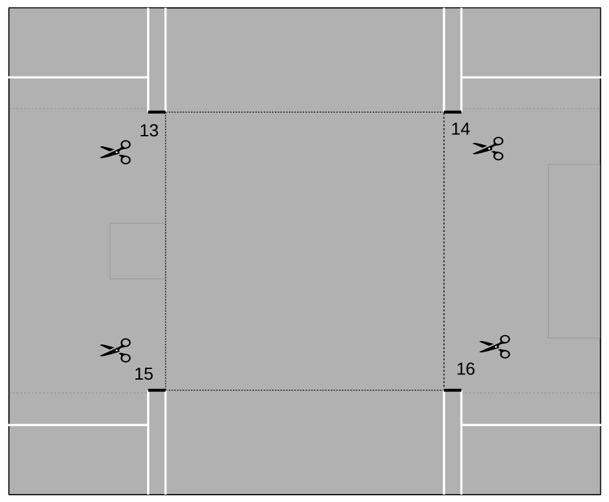

13.

If everything went well, you would produce the following pieces:

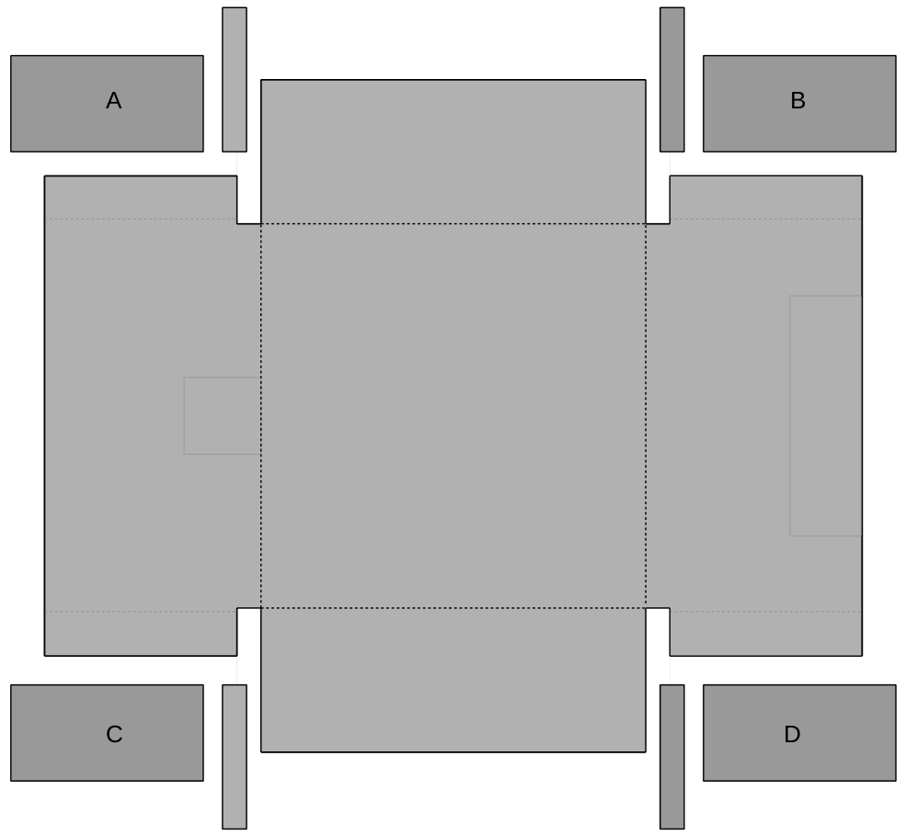

You will use parts denoted from A to D as filter material support in later steps.

You can use other small pieces for practicing hot glue skills...
14.

Draw the lines as depicted below:

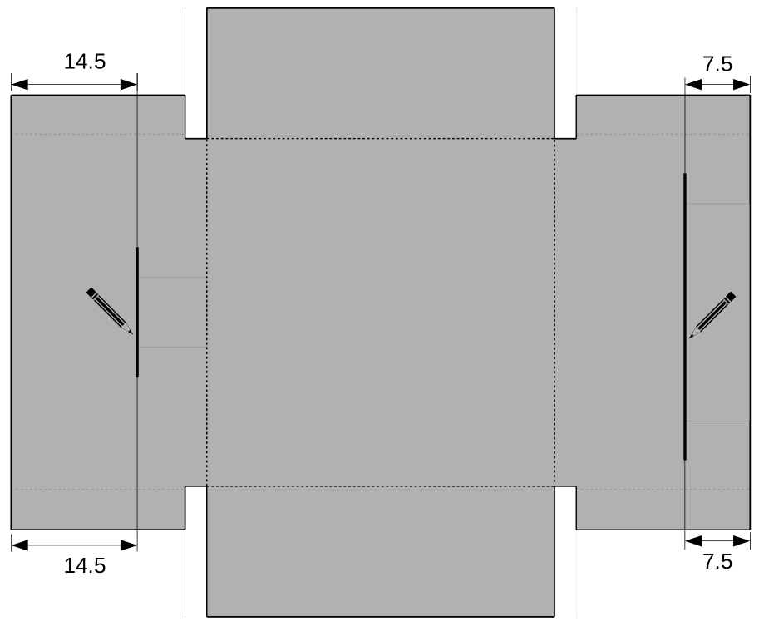

15.

Draw the crossing lines as depicted below:

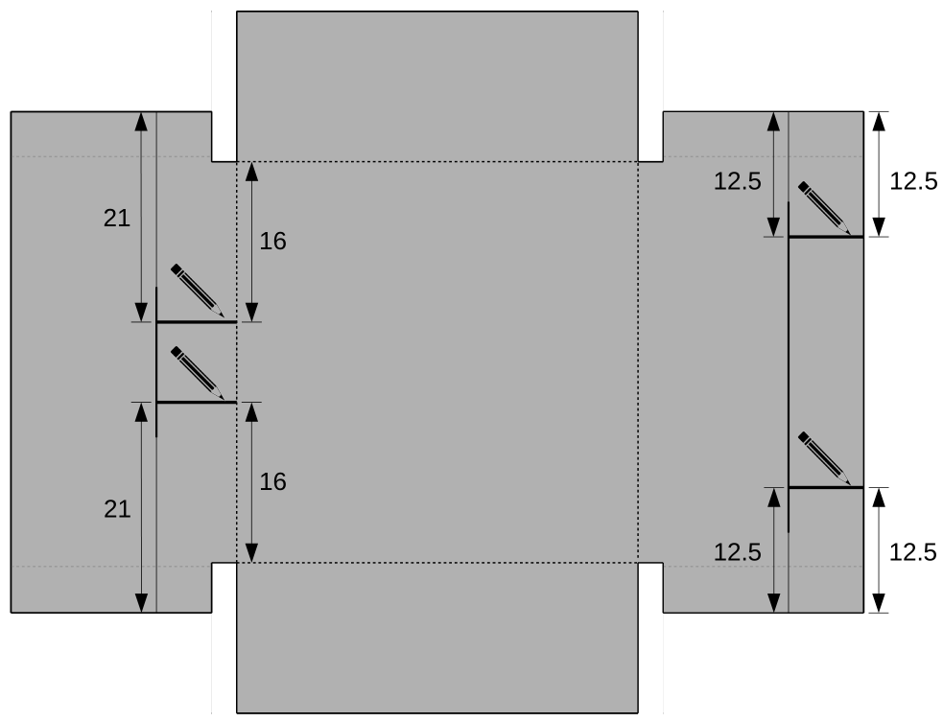

16.

Cut along the lines from 17 to 24:

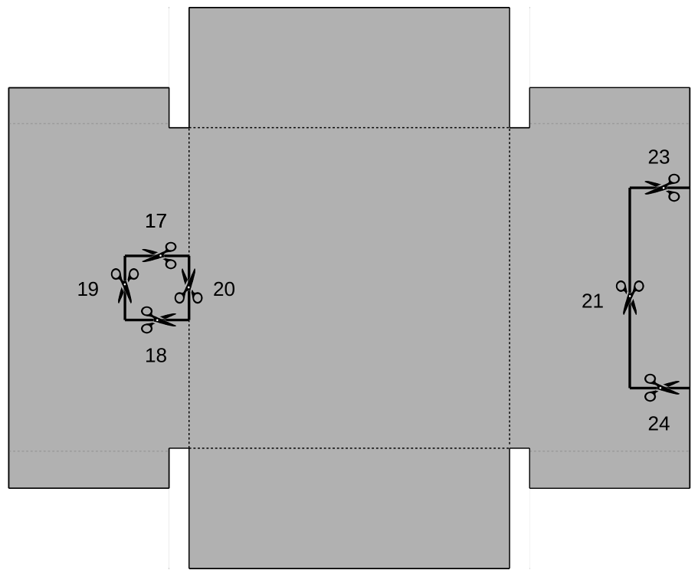

17.

If everything went well, you would produce the shape as depicted below:

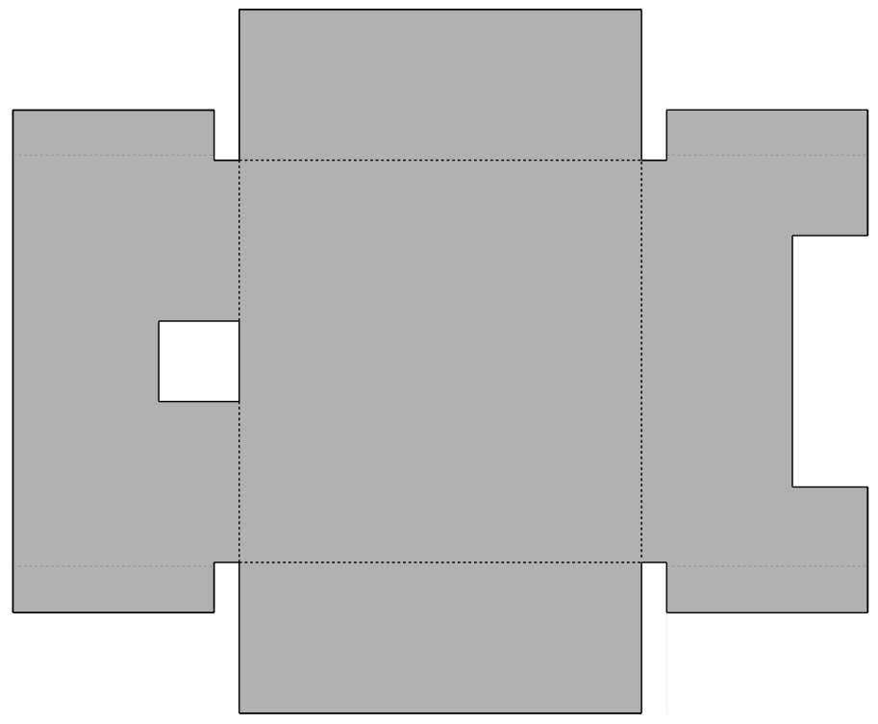

18.

Draw the lines as depicted below:

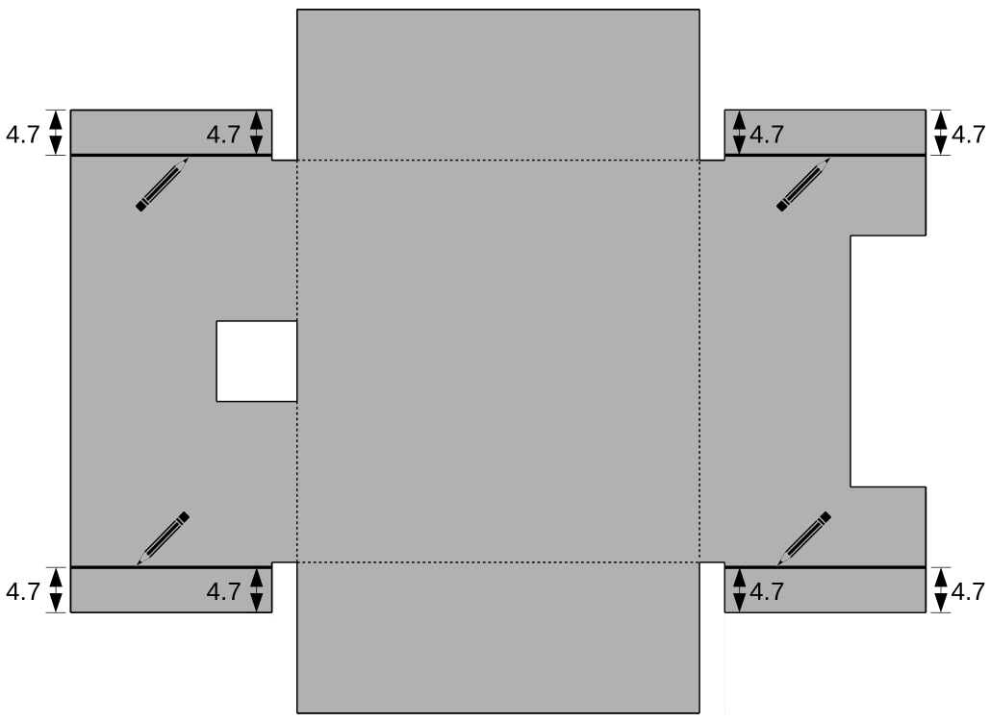

These lines should be drawn 4.7 instead of 5 cm from the edges because we need to take into account the thickness of the cardboard when bending it. This will become more obvious in the next few steps.

19.

In order to assure that the cardboard bends as needed, make shallow cuts along the lines from 1 to 9:

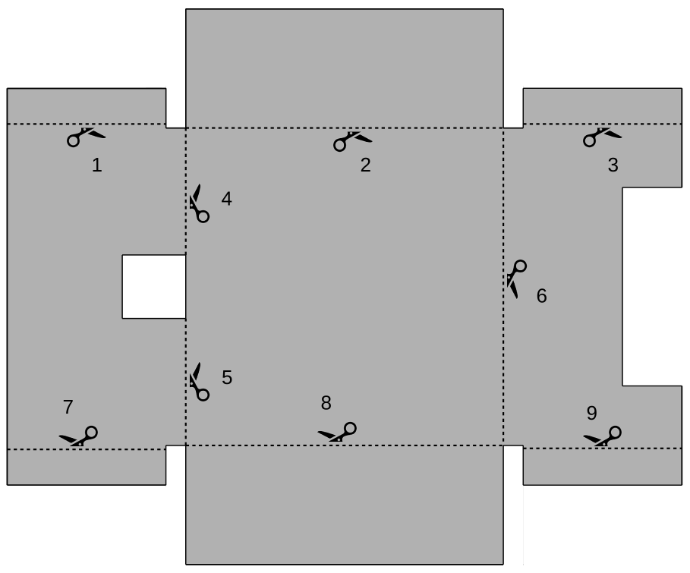

It is sufficient to make a single clean shallow cut along each of the bending lines - you should merely scrape the material, not cut through it.

Depth of these cuts is not critical. It should be approx. 1 mm.

20.

In order to prevent wearing of the box legs, cut out a small triangle a few cm in size from each of the tips from 1 to 6, as depicted below:

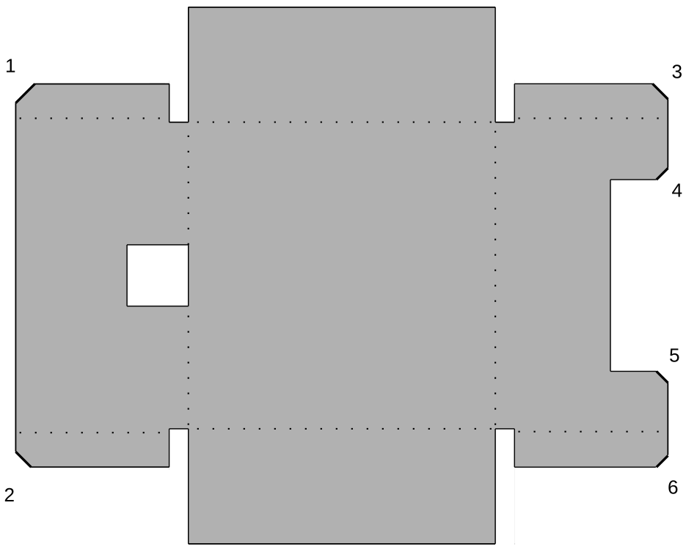

Remember to put the old newspaper underneath the cardboard when cutting.

21.

Flip the plate upside down and then bend its sides slightly upwards along the previously shallowly cut lines:

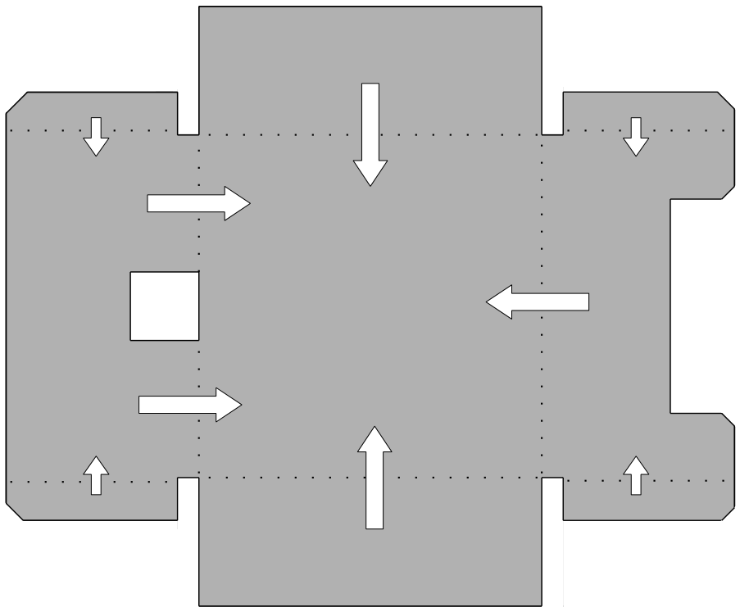

It is not necessary to bend the sides to full 90º, but only to prime i.e. „activate“ each of them.

You will not need any special tool for this. Shallowly cut lines from step 19 will force the material to bend precisely as needed.

22.

Use some acrylic silicone to glue cardboard pieces from A to D from step 13 as depicted below:

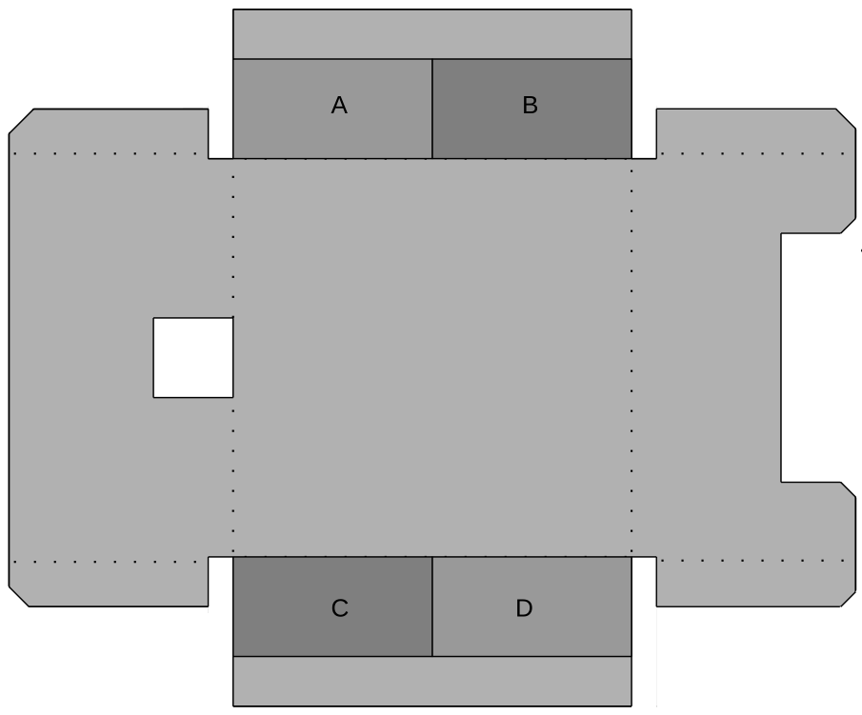

It is sufficient to make a few S-shaped silicone trails onto each of the pieces and then firmly press it to the appropriate place on the main board.

Rotate the pieces a bit left-and-right as you press them in order to better spread out the silicone putty.

Be precise when gluing filter material supports. Take care not to let them pass into the central square part of the board because that would make bending the sides to 90º angle difficult.

23.

This is what the box should look like just before gluing its vertical sides to each other:

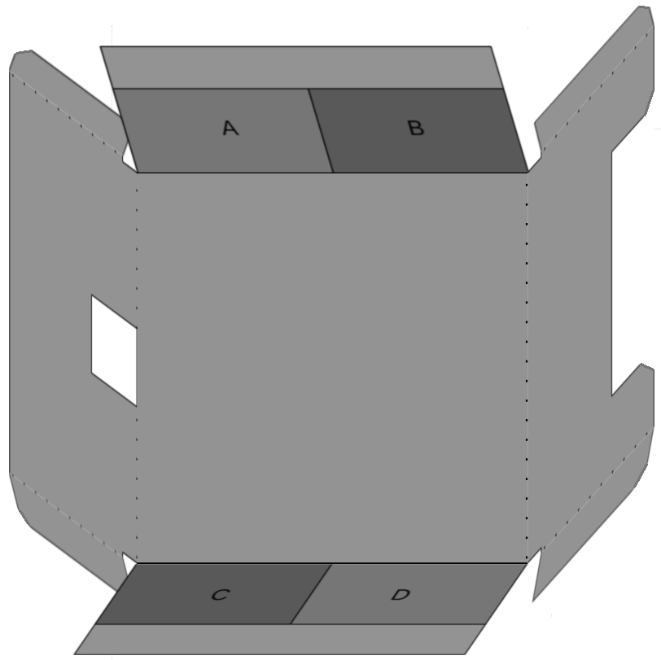

24.

Prepare yourself and the tools for gluing the box:

Load a hot glue stick into the „gun“, turn it on and wait a few minutes for it to warm up.

In order to get accustomed to speed by which one needs to manipulate the hot glue and the cardboard, we suggest that you use a few leftover pieces from step 13 and try to glue them together. Put some hot glue on one of the pieces and then press it with another.

You will notice that hot glue sticks in seconds which is why you have to be precise and work decidedly.

WARNING!

Hot glue is very hot and produces serious burns if accidentally touches skin !!!
25.

Gluing the box

Put enough hot glue onto the area marked as „1“, immediately bend the two neighboring sides to 90º and then bend around and press the area with the glue to its neighboring outer box side.

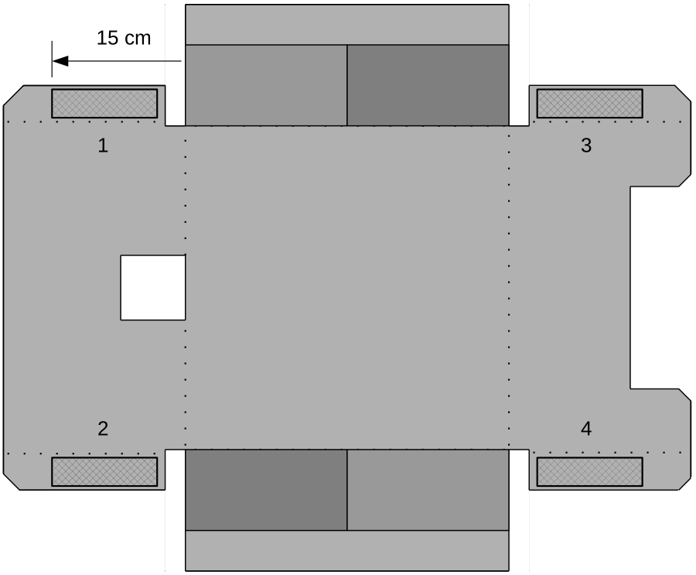

Hold the gluing area in place for a few seconds in order to let the hot glue cool down.

Repeat the process and glue the remaining three sides of the box using the gluing areas from 2 to 4.

26.

PC fans blow the air out though the sticker side, marked with the arrow in the image below. So the sticker side of the fan should look out of the box.

Put the two fans next to each other so that they touch. Sticker side of one of the fans should be turned towards the non-sticker side of the other. That way they will help each other in operation:

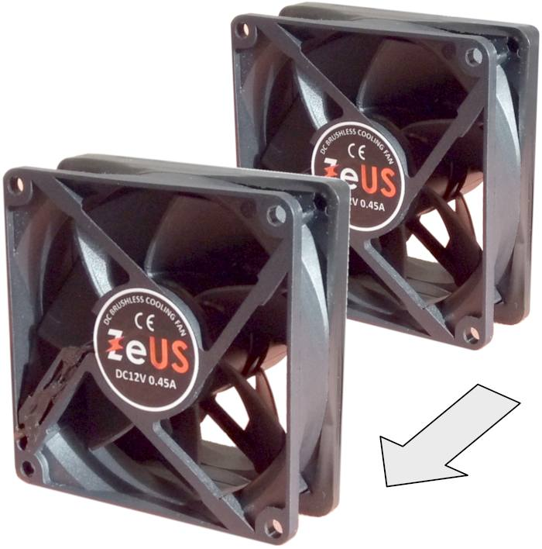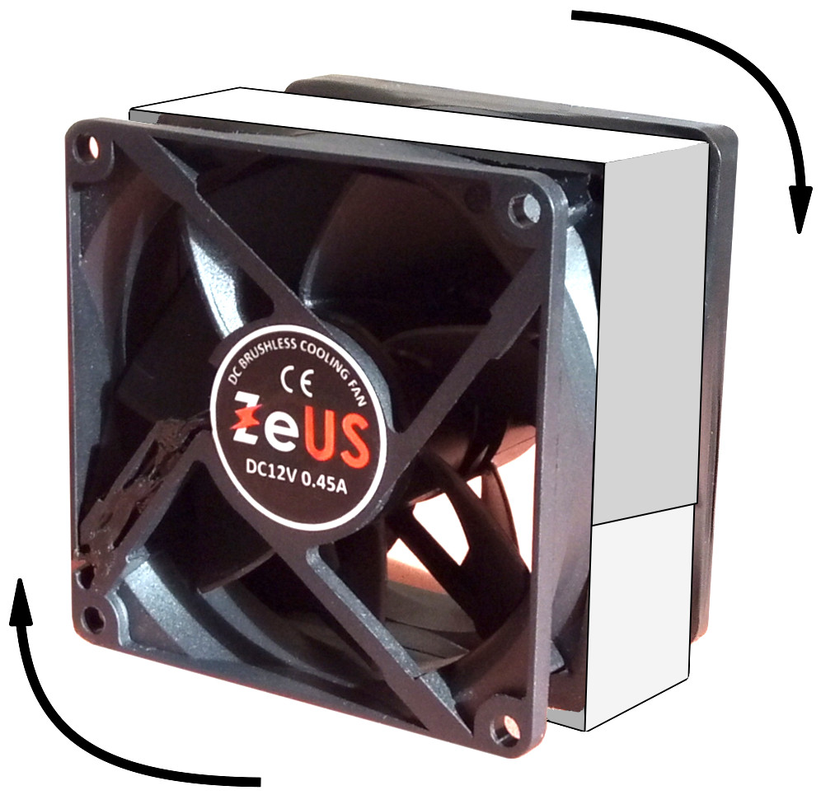

Firmly attach the fans to each other using no less than three full turns of electrical tape.

Before sticking the tape, stretch it a bit and then let it shrink back. Press it to the surface only after it assumes its final somewhat stretched length. This activates special pressure sensitive glue in the tape.

If skilled enough, you can use hot glue instead of tape. There must be no leaks left between the fans.

27.

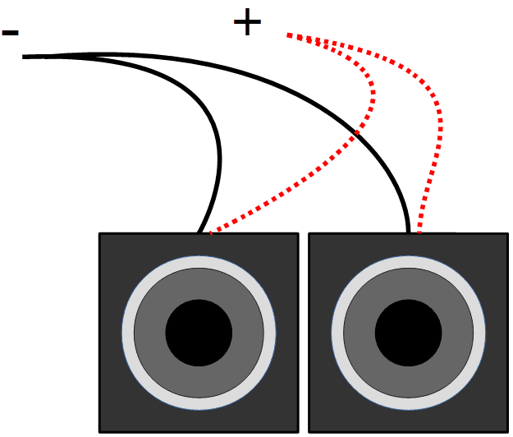
Solder the power supply wires of the two fans so that you attach two + wires to one another, and then two – wires to one another (connect the wires in parallel).

Negative pole of the power supply is marked by black wire insulation. Positive pole is marked by red wire insulation, or by a thin white stripe along its length.

It is important to connect the two black wires to each other, and the two red / stripped wires to each other.

Soldering

In order to solder wires together, you firstly need to strip ~ 1 cm of insulation from their ends. Press a wire to the top of a desk and cut into its insulation very lightly using the box cutter. Make a single dent taking care not to cut off thin and soft copper wires. Then use your finger nails to pull a piece of insulation off the wire.

After you have pulled off some insulation from both wires you are to solder, twist their thin copper strands together a few times to join them mechanically.

Turn the soldering iron on. Put some soldering paste on the twisted copper strands. Paste will remove surface oxide layer from the copper once it gets hot enough. Without the paste soldering would be very troublesome and result in electrically unreliable solder joint.

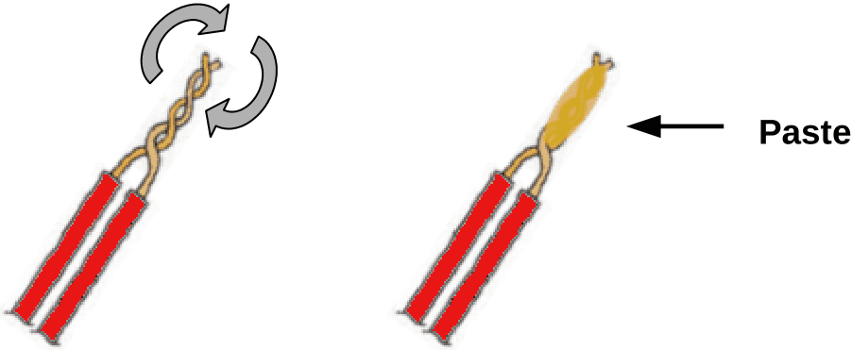

Soldering iron is hot enough if it melts the tin wire momentarily on contact. Touch the tip of the iron with a piece of tin wire to test its temperature.

Take the hot iron in one, and some tin wire in other hand. Press the tip of the iron to the twisted copper wires and wait a few seconds for them to heat up. Wires are hot enough if the paste found on them boils and smokes. Iron transfers heat much better if there is some tin melt on its tip.

Keep pressing the copper wires with the iron and touch them with the tip of the tin wire. The end of the tin wire will melt and flow around the twisted copper strands. It takes ~ 1 cm of tin for a solder joint.

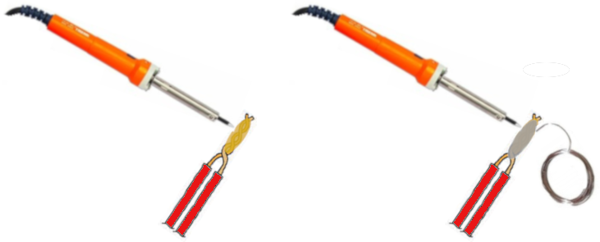

Solder the other two wires together using the same procedure.
28.

Installing fans and cables

Put some silicone putty near the fan opening and then put the fans in place so that they are touching the edges of the opening in the vertical box wall:

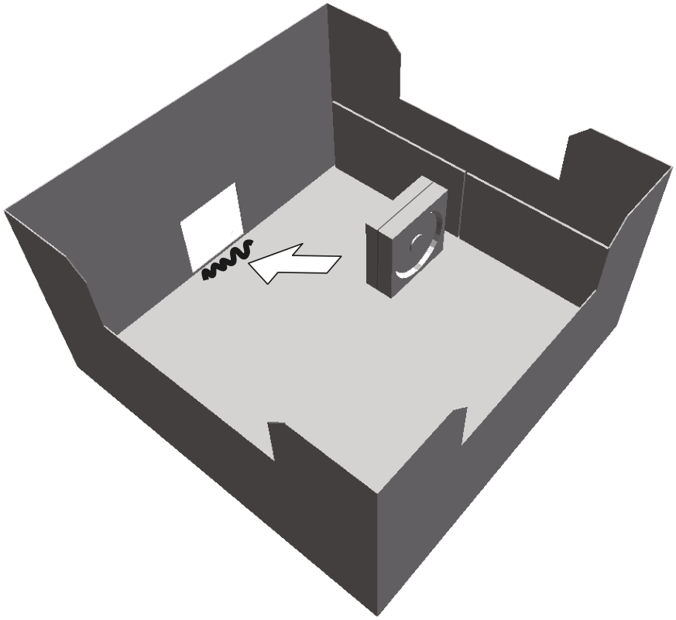

Sticker side of the fan pack should be facing out of the box.

Be precise when positioning the fans as it will simplify making the box airtight in the next step.

29.

Put enough hot glue to all contact edges between the fan pack and the box. The aim is to mechanically firmly fix the fans to the box and to make the box airtight:

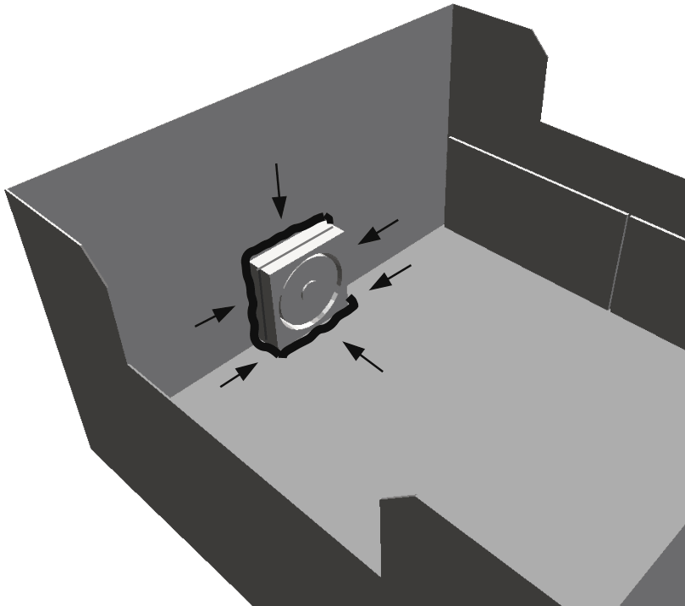

30.

Put some hot glue or silicone putty to all four vertical corner edges to make the box airtight:
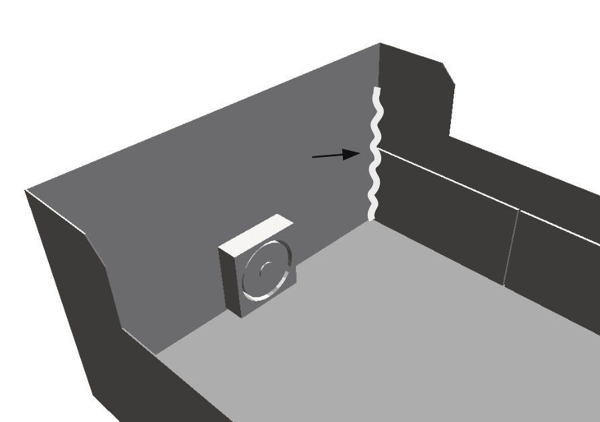
31.

Decide where you want to put the power switch and where you want the power supply cable to enter the box (they do not need to be placed exactly as depicted in the illustration):

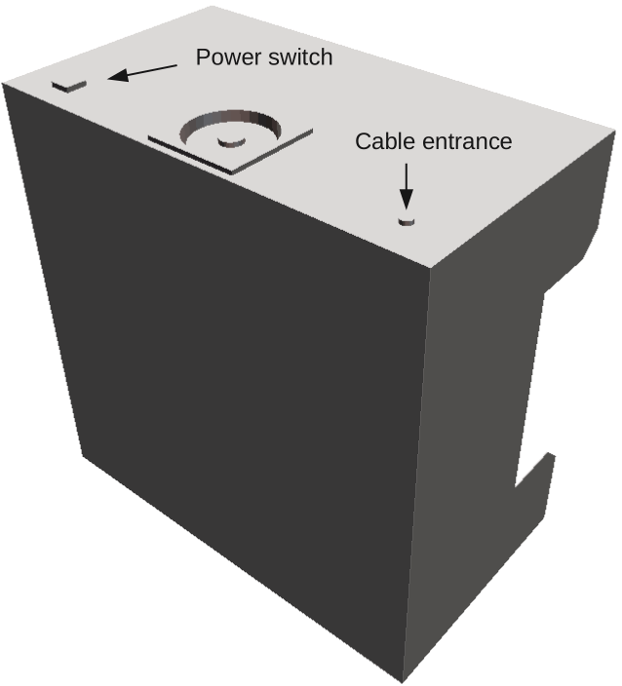

Make the two appropriately sized holes in the cardboard wall.

Mount the switch and fix it to the wall all around the line it touches the box, similarly to fans.

Pull enough power supply cable into the box so that its leads reach the switch.

Pull off ~1 cm of insulation from any of the two power supply cable leads and solder it to one of the switch contacts. After that air-proof the cable hole with some hot glue from the inside.

Sealing the edges around the switch, cable entrance and the fans is crucial for efficient device operation. Should there be any openings left, air being pumped out of the box would simply return back into it so there would be very little under-pressure created inside the box; consequently the surrounding air would have little reason to enter the box through the filtering material and get cleaned.

32.

Select a place inside the box where you want to put the DC-DC converter. Do not glue it to the wall yet as it is necessary to adjust the converter output voltage first:

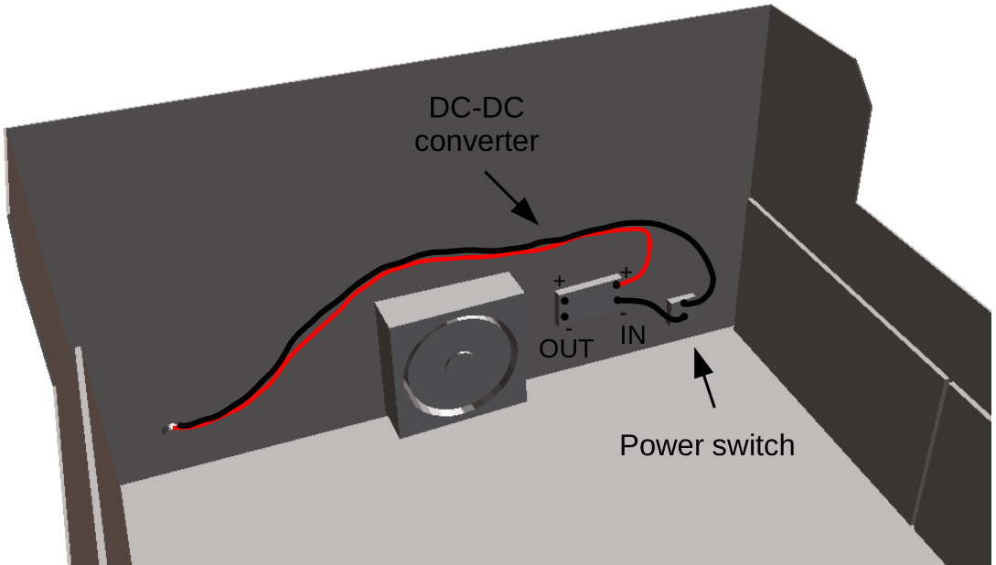

Put the input side of the DC-DC converter circuit board towards the switch.

Pull off ~ 1cm of insulation from the other lead of the power supply cable and solder it directly to the appropriate INPUT PAD of the small converter board. Remember that the positive lead is red while the negative one is black. Positive lead is soldered directly to the converter board in the image above.

Use a piece of cable wire to solder together the other contact of the power switch to the other input pad of the converter. Negative input pad of the converter is connected to the switch in the image above.

It is crucial that you connect positive lead of the power supply cable to positive input pad of the converter, and negative cable lead to the negative input pad.

Do not solder fan power supply wires to the converter yet. You need to adjust the converter output voltage before that.

33.

Put a USB connector on the other end of the power supply cable. Look at the picture below and notice the position of + and – contacts in it. If you decide to use a piece of USB cable instead, remember that the positive lead is red while the negative one is black:

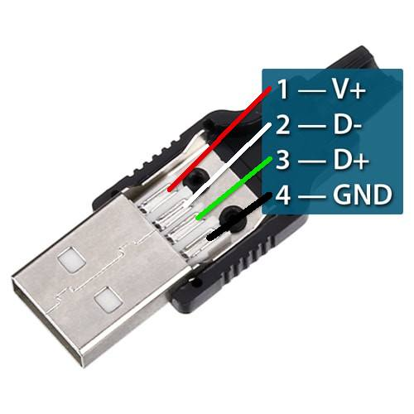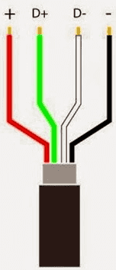

Green and white leads (i.e. the two inner contacts in the USB connector) are used for transferring data and for signaling to the charger that the connected device requires its full power. Signaling is performed simply by short-circuiting those two leads together.

If you use a USB connector, solder a very short piece of wire between the two inner contacts in the plug denoted D+ and D-. Take great care not to make electrical contact between the inner wires and any one of the outer two!

Solder + lead (red) of the air cleaner power supply cable to the positive connector contact, and – lead (black) of the cable to the negative connector contact:
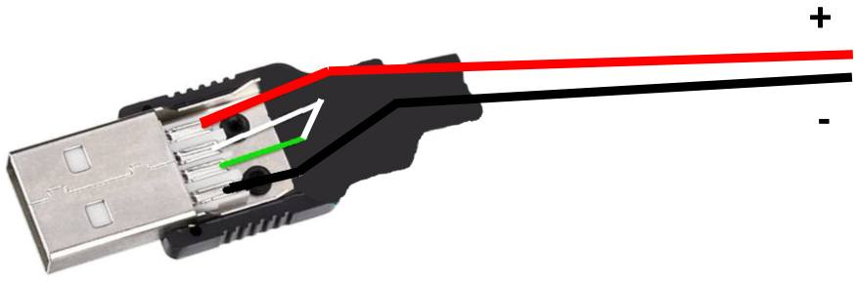

Close the connector and wrap it up with some electrical tape if necessary.

If you use a piece of USB cable, remove ~ 1 cm of insulation from its green and white leads and solder them together. Then wrap the joint up with electrical tape so that it cannot make electrical contact with any of the other two leads within the cable.

Solder + lead of USB cable (red) to + lead of the power supply cable (also red), and wrap the joint up with electrical tape. Then solder – lead of the USB cable (black) to – lead of the power supply cable (also black) and wrap the joint up with electrical tape.

Finally, after you have insulated all three solder joints separately, wrap the whole joint area with a lengthy ~ 30 cm piece of electrical tape to make it secure electrically and tight mechanically:



Remember to pre-stretch the tape before use in order to activate the contact glue in it.

34.

Turn the digital voltmeter on and set it for measuring direct voltage up to 20V DC.

Touch + input pad of the converter with the positive voltmeter probe (red, or the one with red marking on it), while at the same time touching – input pad of the converter with the negative probe (black, or the one with black marking on it). Plug the USB connector into the mobile phone charger and test whether voltmeter reads something close to 5 . 0 V .

If you accidentally swapped the leads in the cable, voltmeter would read – 5 . 0 V or less. If that is the case, unplug the USB connector from the charger and swap the two wires soldered to the DC-DC converter input pads.

DC-DC converter circuit board contains a small trimmer potentiometer for adjusting the output voltage. Turn its knob clockwise to make the output voltage lower, and turn it anti-clockwise to make it higher.

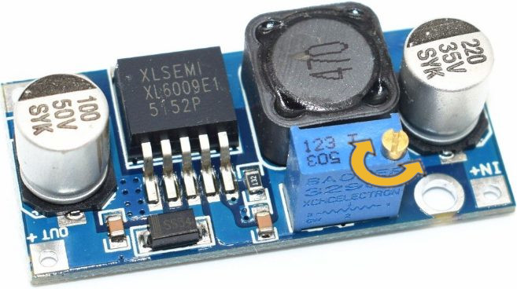
Touch the converter output pads with + and – voltmeter probes and use a miniature screwdriver to adjust the voltage to 17 V. This is much easier to do if a friend holds the probes in place.

Remember to turn off the voltmeter after use.

35.

Solder + and – fan power supply wires to + and – output pads of the converter. Take great care to solder + wire (red, or stripped) to + pad, and – wire (black) to – pad.

This is the complete electric circuit diagram of air room cleaner device:

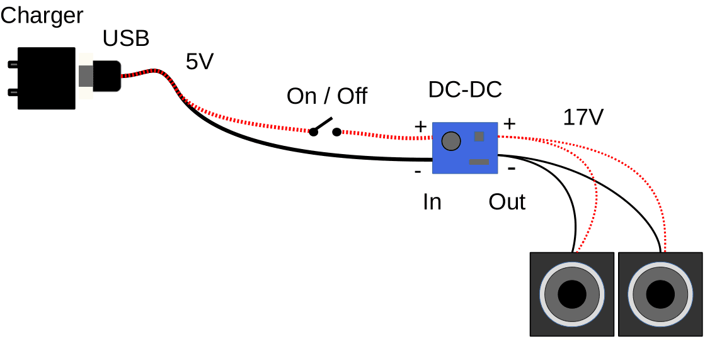

After you have connected and soldered all the components as described so far, tested switch and fan operation and you are positive that everything works OK, glue the internal wiring using the hot glue to several places on the box wall inside the box.

Then put some hot glue onto power switch contacts and DC-DC converted input and output pads. That will bullet-proof solder joints by preventing dangling of the internal wiring due to vibrations.

Wrap the whole DC-DC converter circuit board with a lot (~ 1 m) of electrical tape. Make multiple turns so that a kind of soft but sturdy „housing“ is made around it. Then use hot glue to fix the wrapped converter to the side of the box. Gluing the supply and fan wires near the places where they enter/exit the „housing“ of the converter is very effective in preventing it from ever pealing off the box wall.

36.

The most practical power source for this device is a mobile phone charger able to deliver 5 V / 2 A. Less powerful travel chargers that can output merely 1 A of current are too weak to supply the air cleaner.

DC-DC converter automatically adjusts itself to possible input voltage variations, so you can use some other AC/DC cube, but you will need to measure its voltage and decide how to solder the power supply cable to it.

It it important that AC/DC converter of your choice outputs direct voltage (DC) not higher than 15 V, and that it is able to deliver at least 10 W of power meaning that the product of its output voltage and current is equal or greater than 10. For example, AC/DC wall adapter able to deliver 12 V * 1 A = 12 W is strong enough to power the air cleaner.
37.

Installing the filter material

Check whether filter material fits the box by width. If it is too wide, cut off a few mm from it using a box cutter. If it is a few mm too narrow, that will be easy to fix with silicone putty.

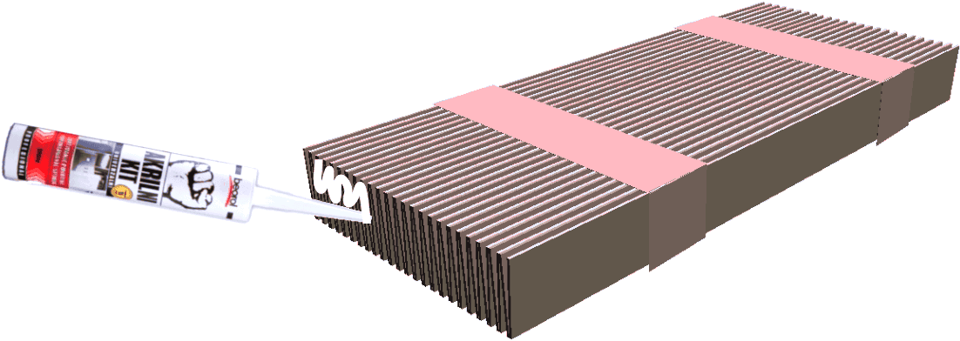

Before you take off the adhesive tape from the filter material pack, put a small amount of silicone putty on its zigzag sides and spread it evenly. This will make installing the filter easier.

38.

Turn the box upside down and put the unpacked filter pack in the middle of its grooved holding place. Carefully remove the adhesive tape - don‘t let the filter material pop out as jack-in-the-box. It is best to have another pair of hands to help you with that.

Spread the pleats evenly over the grooved bottom side of the box:

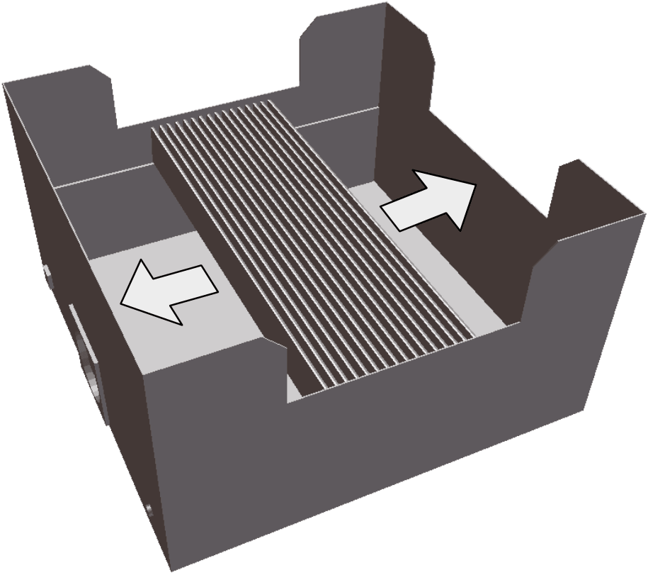
39.

Use a lot of acrylic silicone putty to glue the filter to the box. It is very important that you make every single edge of the material airtight, all the zigzag edges (1) as well as the two straight ones (2) :

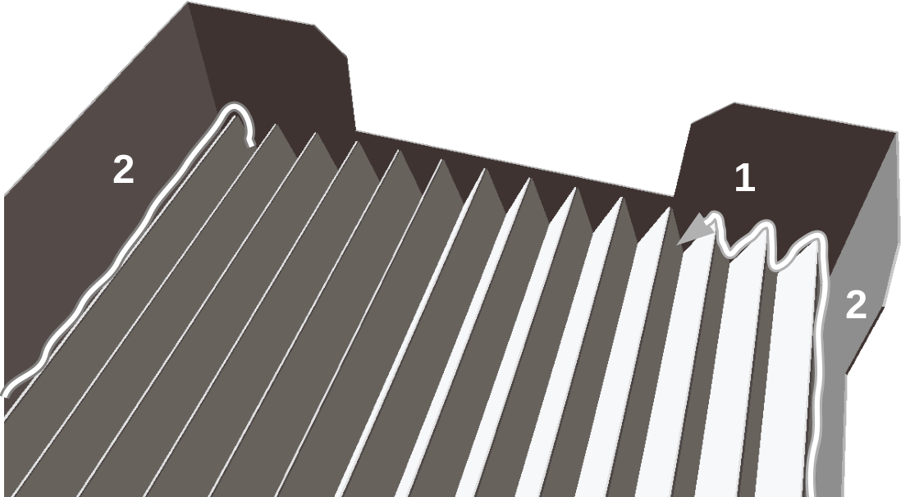

This is the crucial step in making the device. If there are any openings left between the filter material and box walls, the surrounding air would have little reason to flow through the filter material and get cleaned. Such device would be very inefficient in operation.

Squeezing the silicone out of the tube is physically hard. Put some putty to a pair of „V“ zigzag edges and spread it a bit around using the tip of the silicone gun or some other handy tool. Make sure that the edges you are working on are airtight before continuing work on the next pleat.

Rest the hand often. Acrylic silicone takes approximately half an hour to harden, so you don‘t need to hurry. If you missed a spot, it is very easy to fix later with some more putty.

Optimal number of pleats

The more filter material you build into the cleaner, the more efficiently it will work. Relatively high cost of the filter material in comparison to all the other components of the device is the sole reason that one might want to optimize the amount of pleats.

A single pleat („V“) 40 cm wide has surface area: 40 x 2 x 4 cm = 320 cm². Thirty pleats have total surface area: 30 x 320 = 9,600 cm² ≈ 1 m². We believe that this is the minimal amount of material that assures acceptable cleaning speed (see the diagram on page 2).

Maximal amount of material that can be put in a box described in this tutorial is 50 pleats = 1,75 m².
40.

Put the device at the appropriate place of your choice inside the room. The box is designed such that it can be put horizontally in which case it can be used as a kind of a handy night table for toys, mobile phones… It can also be put on the floor next to a wall with its bottom side facing the wall:

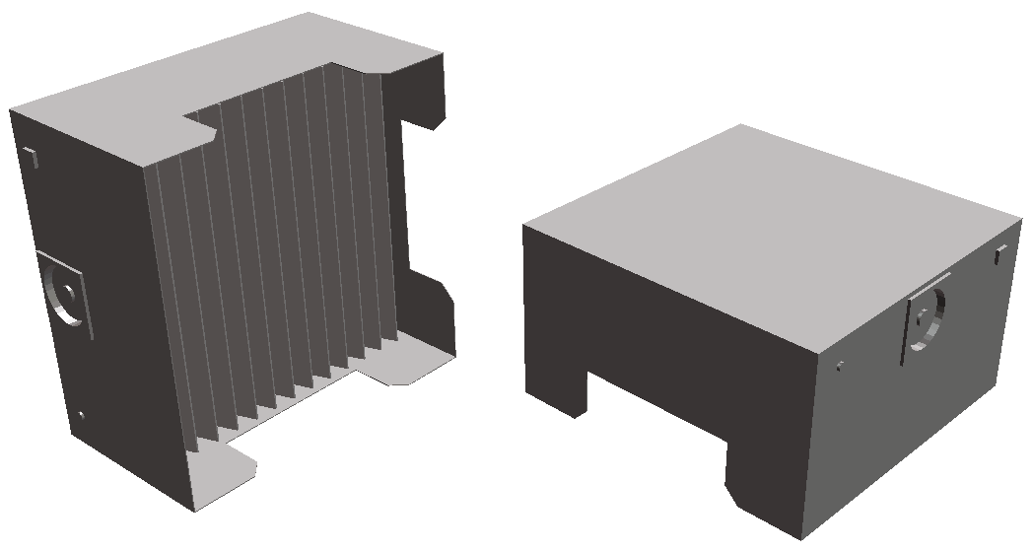

Device is light enough to be hanged on a wall using a pair of screws and short wire hooks.

Please note that PC fans must be positioned VERTICALLY. The reason is that their shafts must be horizontal. Otherwise lubricant would quickly flow down out of the shaft sleeve; such fan would become rather noisy in a day or two, would start vibrating in a week and fail prematurely.

It is best to orient the floor air cleaner such that it blows air in the general direction of the room heat source i.e. a radiator in order to take advantage of thermal air circulation.

Paint the device in your favorite color. We suggest that you use non-toxic acrylic paints – they are dissoluble in water while wet but polymerize and become permanently insoluble once they get dry. They are very inexpensive and durable, come in a plethora of tones and even with some special effects: there are fluorescent acrylic paints, glittering ones… all of that makes them perfect for kids.

Decorate the device using cardboard leftovers. Cut them into convenient shapes and glue them on. Use shiny pearls and buttons to further beautify the cleaner. Kids will love taking part in the process!

- you are very welcome to further enhance, translate and redistribute
this free and open source instruction manual -

LP, Serbia, February 2020

